**3D Portal**

**Steps to setup project**

**Step 1.**

**Set up the Development Environment**

**You need to set up your development environment before you can do anything.**

**Install**[Node.js® and npm](https://nodejs.org/en/download/)**if they are not already on your machine.**

**Then install the**[Angular CLI](https://github.com/angular/angular-cli)**globally.**



**Step 2.**

**Install mysql on machine (xamp / wamp)**

**Import database (portal.sql file on mysql)**

**Step 3.**

**Open project Locally**

* **Open command prompt with project location path**

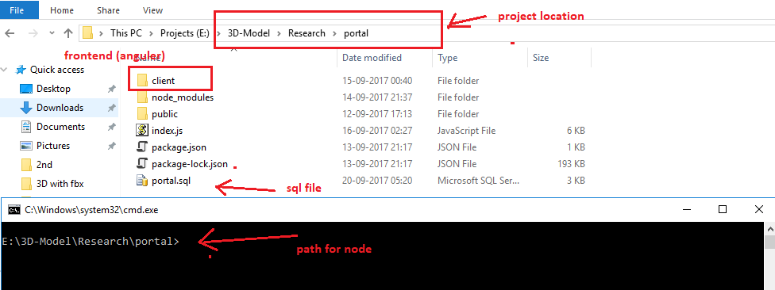

* **Type command npm install (this will install all packages for Nodejs)**
* **Open another command prompt [folder location should be client]**

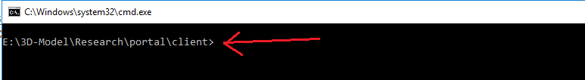

* **Type command npm install (this will install all packages for angularjs)**

**Step 3.**

**To Run Project**

* **Run Node Server**

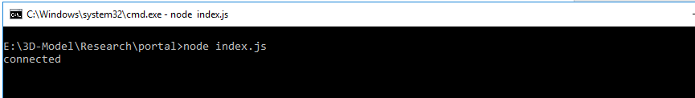

* **Open another command prompt with folder location client**
* **and type ng serve –open command to run project**

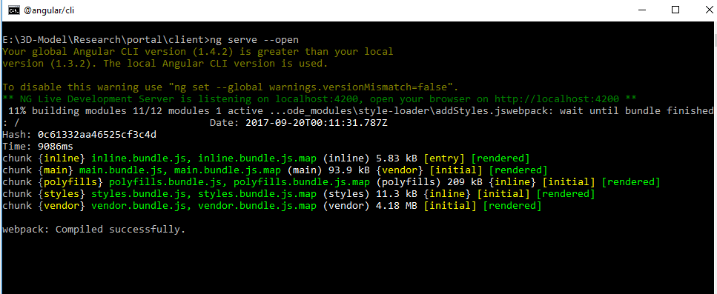

* 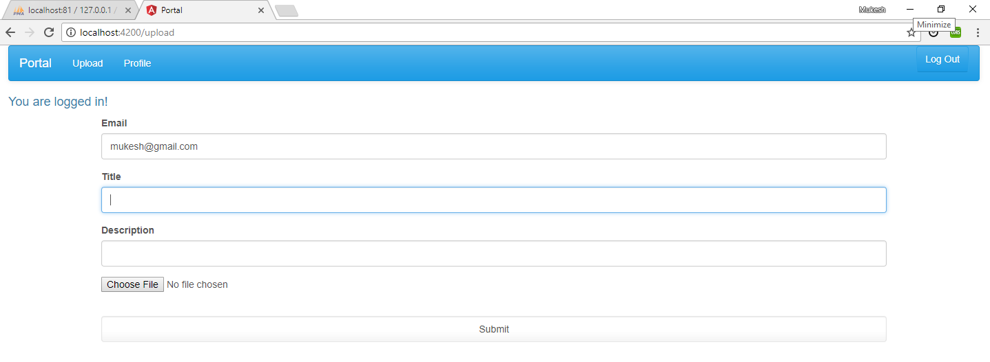**Output**

*Note: Admin login- localhost:4200/admin

User Id - admin

Password- admin123